TEAM A

ENERGY CONSUMPTION ANALYSIS SYSTEM

PYTHON STUDY GROUP SMARTBIXCRUX

2026

TEAM NAMES
- GOMES VIVIAN
- OSENI LATIFAT
- ISMAEL
- OSITADINMA CHIGOZIE

- INTRODUCTION

Access to reliable electricity remains an important development challenge across Africa, particularly in Sub-Saharan Africa. Although the continent has significant energy resources, a large proportion of its population still does not have access to reliable and affordable electricity. The challenge goes beyond simply generating more electricity. It also involves how electricity is distributed, who has access to it, how much electricity is actually being consumed, what it costs, and how reliable the available supply is.
This distinction between electricity access and electricity consumption is important. Access focuses on whether people, communities, businesses and institutions can obtain electricity services, while consumption describes how much electricity is actually being used. A community may technically have access to electricity but still experience low consumption because of unreliable supply, high costs, limited infrastructure or affordability challenges.
The scale of the problem has led to major initiatives aimed at improving electricity access across the continent. One example is Mission 300, a joint initiative led by the World Bank Group and African Development Bank Group, which aims to provide first-time electricity access to 300 million people in Africa by 2030. The initiative recognizes that expanding access will require a combination of grid connections, renewable-energy mini-grids and stand-alone off-grid systems.
Nigeria provides an important context within this wider African situation. As one of the continent's largest and most populous countries, Nigeria has considerable energy resources and electricity-generation potential, yet significant gaps remain between electricity availability, reliable access and actual consumption. Government-led efforts such as the Nigeria Electrification Programme (NEP), the Rural Electrification Agency's activities and newer initiatives such as the Nigeria Distributed Access through Renewable Energy Scale-up (DARES) demonstrate the continuing effort to improve electricity access, particularly in underserved and unserved areas.
These challenges create a need for better understanding of electricity consumption patterns. Energy data can help reveal differences between locations, customer groups and periods of consumption. It can also help identify unusually high consumption, electricity-cost patterns, outage-related issues and areas where further investigation may be necessary.
This project therefore approaches the broader energy challenge from a data perspective. The Energy Consumption Analysis System is a Python-based analytical system designed to transform structured electricity-consumption records into useful information about demand, cost, customer groups, locations and consumption patterns. The project uses a simulated dataset to demonstrate how Python can be applied to an industry-related problem.

2.0 PROBLEM STATEMENT
Despite Africa's considerable energy resources, electricity access and electricity consumption remain major challenges, particularly in Sub-Saharan Africa. The problem is not limited to whether electricity can be generated. Electricity must also reach the people and organizations that need it, remain sufficiently reliable, and be affordable enough for households, businesses and institutions to use.
Nigeria illustrates this challenge. The country has substantial electricity-generation resources, including natural gas and hydropower, yet electricity availability and consumption do not always translate into reliable access for all users. Differences in location, customer type, electricity cost, outages and other factors can influence how electricity is consumed.
Without structured analysis, large amounts of consumption information can remain simply as individual records without providing a clear picture of overall demand or differences between customer groups and locations. Decision-makers may therefore find it more difficult to identify high-consuming customers, compare locations, understand customer segments, examine monthly patterns or recognize cases that deserve further investigation.

2.1 AIM AND OBJECTIVES
The major aim of this project is to develop a Python-based Energy Consumption Analysis System that can analyze structured electricity-consumption records and provide useful insights into consumption, electricity cost, customer groups, locations and usage patterns.
The objectives of the project include:
- Structure electricity-consumption records using Python data structures, particularly lists and dictionaries.
- Validate the dataset by checking for issues such as missing customer identifiers, invalid consumption values, invalid renewable-energy percentages, duplicate records and other inconsistent information.
- Calculate basic electricity-consumption metrics, including total consumption, average consumption, maximum consumption and minimum consumption.
- Analyze electricity costs by calculating individual and overall electricity costs based on consumption and applicable tariffs.
- Identify differences among customers by determining the highest and lowest consumers and applying a consumption classification system based on agreed analytical thresholds.
- Analyze consumption by location in order to compare electricity-use patterns across Lagos, Abuja and Ibadan.
- Analyze consumption by customer type to examine differences among residential, SME, industrial, hospital, school and agricultural users.
- Examine monthly consumption patterns across the available period in order to identify changes in electricity use over time.
- Identify high-attention customers using defined analytical criteria that may indicate unusually high consumption or other conditions requiring further investigation.
- Develop an interactive Python menu system that allows users to access the different analytical functions and return to the main menu until they choose to exit.
- Demonstrate how Python fundamentals can be applied to an industry problem, while creating a foundation that can later be upgraded to work with external datasets, Pandas and visualization tools.

3.0 INDUSTRY RELEVANCE
Energy is closely connected to economic and social development. Reliable electricity supports businesses, schools, hospitals, agriculture, industries and households. When electricity is unavailable, unreliable or unaffordable, the effects can extend beyond the electricity sector itself and affect productivity, education, healthcare and economic activity. For this reason, energy-sector decisions cannot depend only on the amount of electricity being generated. There is also a need to understand where electricity is being consumed, who is consuming it, how much is being consumed, what it costs and how usage changes over time.
The Energy Consumption Analysis System demonstrates how data analysis can contribute to this type of understanding. By organizing electricity records according to customer type, location and month, the system provides a simple way of examining patterns that may otherwise be difficult to see from individual records.
The project's industry relevance can be considered in several areas.
- Energy Planning: Consumption data can help analysts understand patterns of electricity demand across different locations and customer groups. This type of information can support further investigation into where electricity infrastructure or additional capacity may be required.
- Energy Efficiency: Unusually high consumption may indicate an opportunity to investigate energy-use behaviour or efficiency. The system's consumption calculations and customer classification provide a starting point for identifying such cases.
- Renewable Energy Planning: The dataset includes renewable-energy share as one of its variables. Examining consumption alongside renewable contribution can help analysts identify situations where high-demand customers have relatively low renewable-energy participation and may therefore be candidates for further renewable-energy assessment.
- Infrastructure and Access Planning: Differences in consumption between locations and customer categories can provide useful information for understanding demand patterns. In the wider energy sector, this type of information can complement electricity-access initiatives by helping stakeholders understand the characteristics of the users they are trying to serve.
- Electricity Cost and Affordability: Electricity consumption and tariff information allow the system to examine cost alongside usage. This is relevant because access to electricity does not necessarily mean that electricity services are affordable for every household or organisation. Understanding consumption-cost relationships can therefore contribute to broader discussions around affordability.
- Business Intelligence: Energy companies and other organisations that manage electricity services work with large volumes of customer and consumption information. A structured analytical approach can help turn these records into information that supports customer management, demand assessment and operational decision-making.
- Evidence-Based Decision-Making: The broader industry context demonstrates why data professionals are increasingly relevant to the energy sector. Energy programmes and investments require information about demand, access, customers, infrastructure and performance. Data analysis can help convert raw records into evidence that supports better questions and better decisions.

5.0 DATASET DESCRIPTION
An energy consultancy firm collected electricity consumption information from different customers to support the analysis of electricity consumption pattern, electricity costs, custom customer categories, locations, monthly consumption, outages, renewable energy usage, and payment status.
5.1 Size of the Data
The dataset contains 20 sample electricity consumption records. Each record represents the monthly electricity activity of a customer.
5.2 Data Structure
The sample data collected is a List of dictionaries where each dictionary represents one customer record and each key represents a data field.
The Dictionary contains:
- Customer ID: Unique Identifier assigned to each customer e.g. C019
- Customer Name: Name of the customer
- Customer Type: Category of customer e.g. Residential, SME, Industrial, Hospital, School, etc
- Location: Geographic location of the customer. The project only focused on Lagos, Ibadan and Abuja
- iMonth: The month represented by the record. This spans from January through June
- Consumption: This represents the Electricity consumed by customers in a particular period. This is represented in Kilowatt Hour (Kwh).
- Tariff: Electricity cost applied per kilowatt hour. It is usually in Monetary form per kilowatt hour
- Peak Consumption: Electricity consumed during peak periods. It is also measured in kilowatt per Hour
- Renewable Share: Percentage of consumption associated with renewable energy
- Outage Hours: Number of hours when there is no electricity supply
- Payment Status: Customer Payment Status. It is either paid or pending.

5.3 Dataset Limitation
The dataset is a simulated instructional dataset and should not be interpreted as official electricity consumption statistics for Nigeria. It is designed to demonstrate the application of Python programming and analytical thinking to an energy consumption problem.

6.0 METHODOLOGY
This project adopted a practical Python-based approach to examine electricity consumption patterns using a structured sample dataset. The methodology was designed around the learning objectives provided in the project guide and focused on applying fundamental Python concepts to an energy-related problem.
6.1 Data Source and Structure
The project used a 20-record simulated instructional dataset embedded directly in the Python program. Each record was represented as a dictionary within a Python list. The dataset contains information relating to customer identification, customer type, location, month, electricity consumption, tariff, peak consumption, renewable energy share, outage hours and payment status.
The dataset was treated as a sample for demonstrating analytical and programming techniques. It is therefore not presented as official electricity consumption data for Nigeria. The current version of the project does not use external CSV files or advanced data-analysis libraries, in accordance with the stage of the Python.
6.2 Data Preparation and Validation
The dataset was first examined using basic Python operations to understand its structure and the information contained in each record. Data validation was considered as an important part of the process. Checks were designed around the uniqueness of customer IDs, positive consumption values, valid renewable-energy percentages, reasonable outage hours, valid payment statuses and consistency in customer-type classifications.
These checks help ensure that the data being analyzed follows the expected structure before calculations are performed. The project guide also recommends the development of a validate_data() function to identify issues such as negative consumption, invalid renewable percentages and missing customer information.
6.3 Data Processing and Programming Approach
The analysis was developed using fundamental Python concepts already covered in the training. These include variables, lists, dictionaries, indexing, conditional statements, for and while loops, nested while loops, functions, parameters and return statements.
The analytical processes were separated into individual functions rather than being written as one large block of code. Functions were developed for the major operations required by the project, including total and average consumption, highest and lowest consumers, location analysis, customer-type analysis and monthly analysis. The functions allow the same calculations to be reused when the user interacts with the system.
6.3.1 Calculation approach: Totals and averages were computed by looping through the list and accumulating values in running variables (total_consumption, total_electricity_cost). Extremes (highest/lowest consumer) were found by initializing a reference record and comparing each subsequent record against it using if statements.
6.3.2 Grouping approach: For location, customer type, and month, a dictionary was pre-populated with each category as a key (e.g. {"Lagos": 0, "Abuja": 0, "Ibadan": 0}), then each customer's consumption was added to the matching key inside a loop. This is the group-accumulate-compare pattern the guide describes.
6.3.3 Classification and flagging: Consumption was classified into Low (<500 kWh), Medium (500–999 kWh), and High (≥1000 kWh) using if/elif/else. An attention flag was raised where consumption was ≥1000 kWh and renewable share was below 15%, combining a comparison and a logical ‘and’.
6.4 Functions and Menu Development
To make the analysis reusable and organized, the major analytical operations were converted into Python functions. Functions were developed for tasks such as calculating total and average consumption, identifying the highest and lowest consumers, analysing locations, analysing customer types, analysing monthly consumption and identifying high-attention customers.
The functions were subsequently connected to an Energy Consumption Analysis Menu System. The menu provides users with numbered options for accessing the different analyses. A ‘while loop’ was used to keep the system running until the user selects the exit option. A nested while loop was also incorporated to demonstrate how location and customer-type selections can be handled together.
3.5 Presentation of Results
The outputs generated by the Python program will be presented separately in the Analysis and Results section of the report. This section will interpret the consumption patterns, customer classifications, location differences, customer-type differences and monthly patterns obtained from the dataset.
The methodology therefore describes how the data was structured, validated, processed and analysed, while the subsequent analysis section will focus on what the results show and what those results mean.

7.0 ANALYSIS AND DISCUSSION
The analysis provides an overview of how electricity demand is distributed within the sample dataset. These results are intended to demonstrate the application of Python programming and basic energy-consumption analysis rather than represent official electricity statistics.
7.1 Total and Average Electricity Consumption
The total electricity consumption recorded across the 20 customer records was 24,240 kWh, while the average consumption was 1,212 kWh per customer. The total consumption represents the combined electricity demand of all customers in the dataset, while the average provides an indication of the typical consumption level per customer.
7.2 Highest and Lowest Consumers
The system compared the electricity consumption of all customers to identify the customer with the highest consumption and the customer with the lowest consumption. This comparison helps to show the variation in electricity demand among the customers in the dataset. Identifying the highest and lowest consumers also provides a basis for further analysis, as customers with significantly higher consumption may require greater attention to energy efficiency, while customers with lower consumption may have different energy-management requirements. The highest consumer is the Industrial Works Ltd, 3,600 kWh while the lowest consumer is Hope Residence, 190 kWh
7.3 Electricity Cost Analysis
The electricity cost analysis examined the financial implication of electricity consumption using the consumption value and the applicable tariff per kilowatt-hour. This analysis provides an additional perspective on energy use because electricity consumption has a direct financial implication. The Total Electricity Cost is ₦2,920,000
7.4 Customer Consumption Classification
The customers were classified according to their electricity consumption levels. Customers consuming below 500 kWh were classified as Low, those consuming between 500 and 999 kWh were classified as Medium, while customers consuming 1,000 kWh and above were classified as High. The classification makes it easier to group customers according to their level of electricity demand. It also provides a simple basis for identifying customers who may require different energy-management approaches.

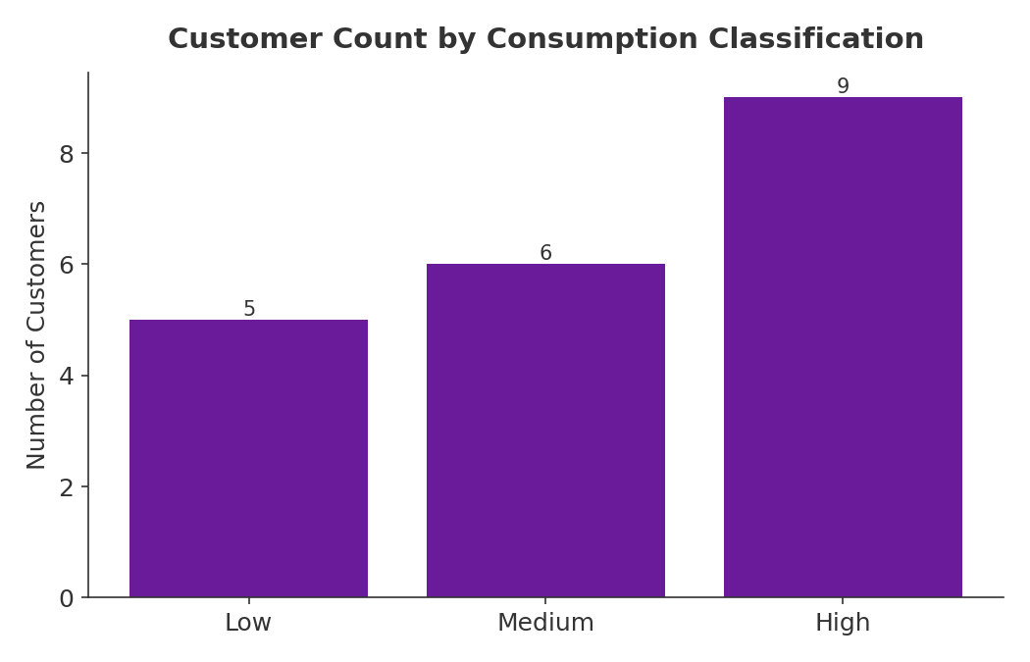

7.5 Location Analysis
The location analysis examined electricity consumption across Lagos, Abuja and Ibadan. Lagos recorded the highest total electricity consumption at 9,760 kWh, followed by Abuja with 8,090 kWh, while Ibadan recorded the lowest total consumption at 6,390 kWh. The results show that electricity consumption was not evenly distributed across the three locations. Lagos accounted for the highest consumption in the sample, while Ibadan recorded the lowest. This demonstrates how location-based analysis can be used to compare electricity demand across different areas.

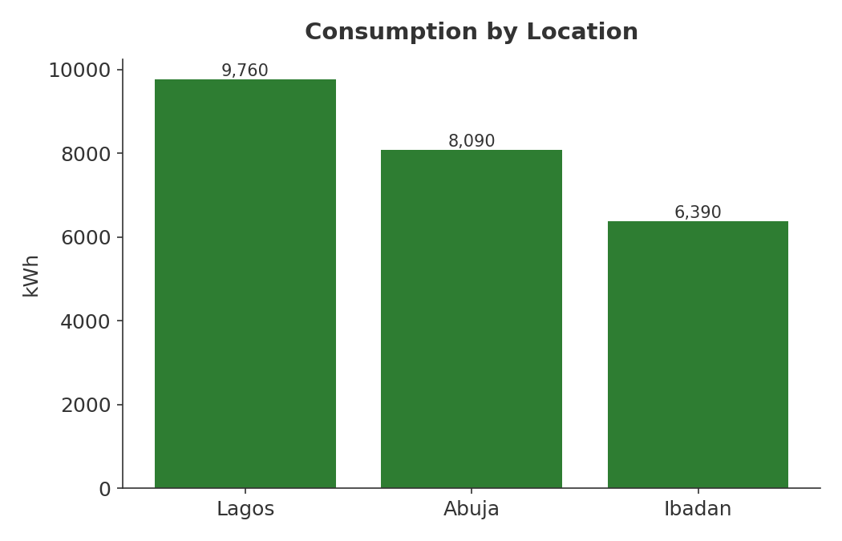

7.6 Customer-Type Analysis
The customer-type analysis examined electricity consumption across the six customer categories represented in the dataset: Residential, SME, Industrial, Hospital, School and Agricultural. Grouping the records according to customer type makes it possible to compare the electricity demand associated with different categories of users. The Industrial consumes 9,600 kWh, Hospital - 4,150 kWh, SME - 4,050 kWh, Agricultural - 3,580 kWh, School - 1,640 kWh, Residential - 1,220 kWh. Industrial is nearly 40% of total consumption despite being only 3 of the 20 records indicating a small number of customers driving a large share of demand..

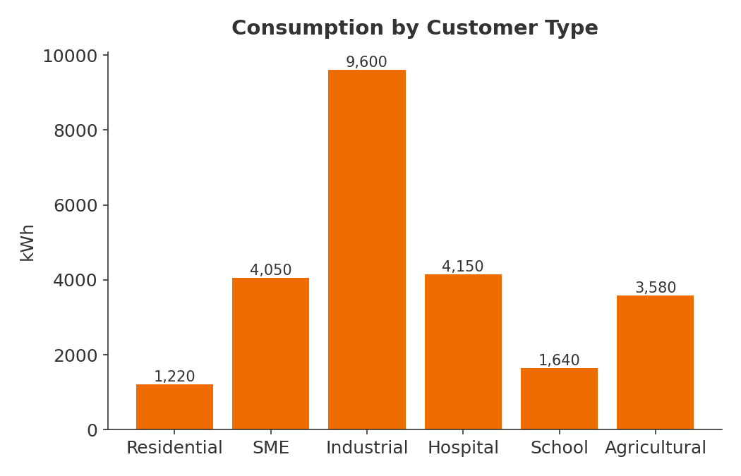

7.7 Monthly Consumption Analysis
The monthly analysis examined electricity consumption across the months represented in the dataset, from January to June. The monthly totals for January is 2,580, February - 1,940, March - 6,050, April - 2,200, May - 3,750, June - 7,720. June is highest, February lowest, but there's no smooth upward trend so it jumps around. This matters for interpretation (see limitations below).

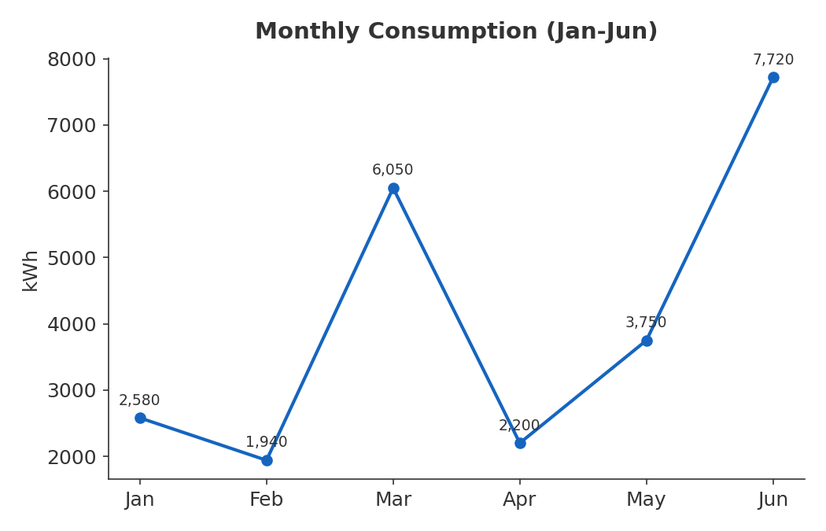

7.8 High-Attention Customer Analysis
The high-attention analysis identified customers who recorded electricity consumption of 1,000 kWh or more while having a renewable energy share below 15%. 4 customers were flagged High Attention — Prime Plastics, Lakeside Hotel, Naija Foods Ltd, Industrial Works Ltd. All four are Industrial or SME accounts with high consumption and low renewable share, which is exactly the rule intended to catch.

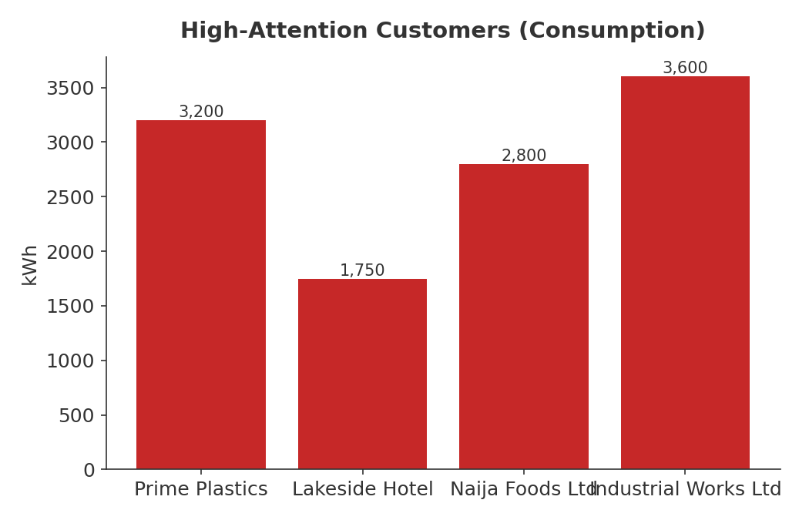

- FINDINGS
The findings show that the sample dataset contains noticeable differences bin electricity consumption across locations, individual customers, customer types and months. The following can be deduced from the analysis;

- Industrial customers account for the largest share of consumption — 9,600 of 24,240 kWh (about 40%) from just 3 records, confirming the guide's example finding about industrial load concentration.
- A small group of high-volume customers drives most of the attention flags — all 4 flagged customers are Industrial or SME, none are Residential, Hospital, School, or Agricultural.
- Lagos consumes the most overall, but not by a wide margin — 9,760 kWh vs Abuja's 8,090 and Ibadan's 6,390, so demand is fairly distributed across the three locations rather than concentrated in one.
- Monthly consumption does not show a clean trend — it rises and falls (Jan 2,580 → Feb 1,940 → Mar 6,050 → Apr 2,200 → May 3,750 → Jun 7,720), suggesting the swings are driven by which customers happen to fall in each month rather than a real seasonal pattern.
- Nearly half the customer base (9 of 20) falls into the High consumption band, but only 4 of those 9 are flagged for attention — meaning the classification (volume-based) and the attention flag (volume + renewable share) are catching different things, and that distinction is doing real analytical work.

9.0 RECOMMENDATIONS
Based on the analysis and findings from the Energy Consumption Analysis System, the following recommendations are proposed:
- Promote energy – efficiency practices among high-consuming customers. Customers with high electricity consumption should be encouraged to adopt energy – efficient practices and equipment to reduce unnecessary electricity use and associated costs.
- Prioritize the 4 High-Attention customers (Prime Plastics, Lakeside Hotel, Naija Foods Ltd, Industrial Works Ltd) for detailed energy-efficiency or renewable-integration assessments, since they combine high consumption with low renewable share.
- Treat monthly figures with caution for planning purposes until the dataset includes multiple months per customer. Monthly totals reflect which customers appear in each month, not real seasonal demand.
- Investigate why Industrial customers show such low renewable share relative to their consumption volume. This is where renewable-energy or solar interventions would likely have the most impact.
- Since High-classified customers (9) outnumber High-Attention flagged customers (4) by more than double, consider whether the attention rule should also catch large non-industrial consumers, such as hospitals, which are high-consumption but currently exempt because of their renewable share.
- Expand the location and customer-type breakdown into a cost view, not just a consumption view because cost is only calculated per customer, not aggregated by location or type, which would show whether high-consumption groups are also the highest-cost groups.
- Improve the dataset for future analysis. Future versions of the system should use a larger and more representative dataset covering a longer period and more customer records. Additional variables could also improve the depth of analysis and make the results more useful for practical decision-making.

10.0 LIMITATIONS
The following limitations were identified in the Energy Consumption Analysis System:
- The analysis was based on only 20 customer records which is a small dataset size. This limits the extent to which the results can represent a wider population of electricity consumers.
- The dataset is simulated, not sourced from an actual utility or NERC, and should not be presented as representing real Nigerian electricity consumption.
- Only 20 records span 6 months, with each customer appearing in a single month — this means monthly totals cannot show a genuine trend over time for any individual customer.
- The attention-flag rule is a single fixed threshold (consumption ≥1000 kWh and renewable share <15%), which is a reasonable starting rule but hasn't been validated against real utility risk criteria.
- Cost, payment status, and outage hours were captured in the data but not yet analyzed — the current system covers consumption-based questions well but leaves affordability and reliability questions unexplored.

- CONCLUSION
The Energy Consumption Analysis System successfully demonstrated how Python can be used to organize, process and analyze electricity consumption data. Using a structured dataset of 20 customer records, the system was able to calculate total and average electricity consumption, identify high- and low-consuming customers, classify customers according to consumption levels, compare consumption across locations and customer types, examine monthly consumption patterns, analyze electricity cost and identify customers requiring higher attention. The analysis recorded a total electricity consumption of 24,240 kWh, with an average of 1,212 kWh per customer. The location analysis also showed differences in consumption, with Lagos recording the highest total consumption, followed by Abuja and Ibadan. Although the project was developed using a small simulated dataset and basic Python programming concepts, it demonstrates the value of data analysis in understanding energy-consumption patterns. The system provides a foundation that can be expanded with larger and more representative datasets, additional variables and more advanced analytical techniques.

